Table 1

Gerko Vink

Characteristics of respondents by background variables and by the 10 explanatory variable scales

Table of Contents

Packages used 1

Load the data 1

Female 2

Session Info 3

Document info 4

# Packages used

For this document we use the following packages

library(dplyr) # Data manipulation  
library(mice) # Data imputation  
library(magrittr) # Pipes  
library(purrr) # Functional programming  
library(haven) # Import data  
library(DT) # Interactive tables  
library(ggplot2) # Plotting device  
library(reshape2) # Data shaping  
library(labelled) # Advanced labelling  
library(tibble) # Tibbles

# Load the data

load(file = "../Workspaces/5. Preparation Imputed Datasets.Rdata")

# Female

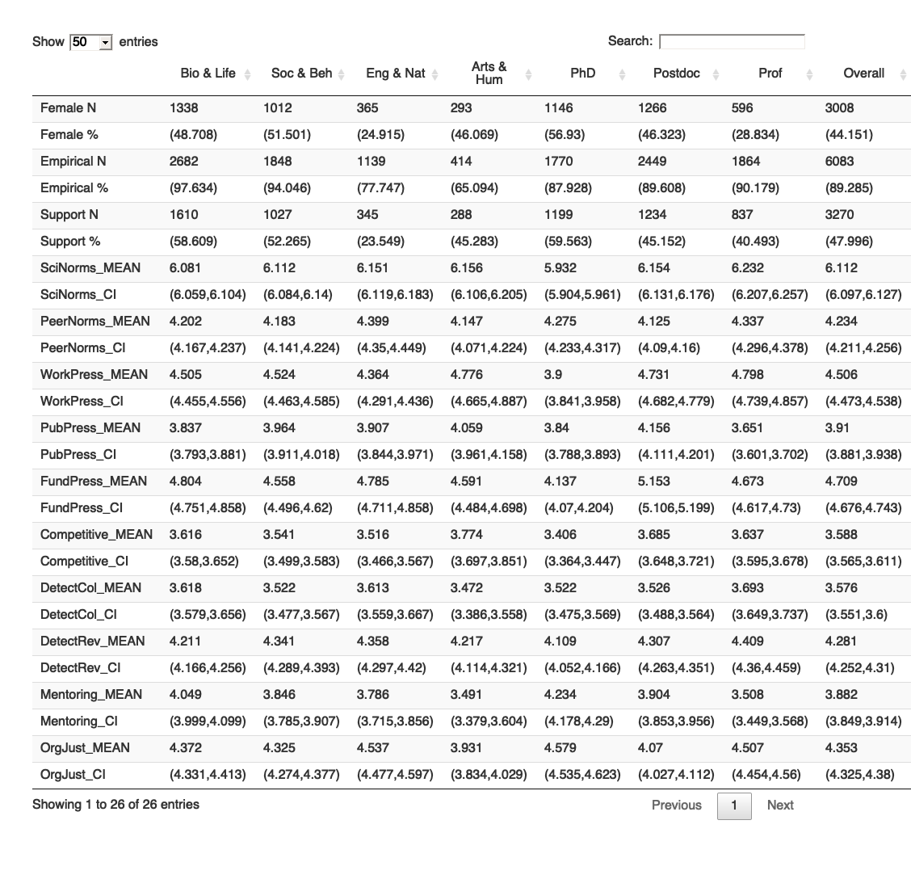

## Bio & Life Soc & Beh Eng & Nat Arts & Hum  
## Female N 1338 1012 365 293  
## Female % (48.708) (51.501) (24.915) (46.069)  
## Empirical N 2682 1848 1139 414  
## Empirical % (97.634) (94.046) (77.747) (65.094)  
## Support N 1610 1027 345 288  
## Support % (58.609) (52.265) (23.549) (45.283)  
## SciNorms_MEAN 6.081 6.112 6.151 6.156  
## SciNorms_CI (6.059,6.104) (6.084,6.14) (6.119,6.183) (6.106,6.205)  
## PeerNorms_MEAN 4.202 4.183 4.399 4.147  
## PeerNorms_CI (4.167,4.237) (4.141,4.224) (4.35,4.449) (4.071,4.224)  
## WorkPress_MEAN 4.505 4.524 4.364 4.776  
## WorkPress_CI (4.455,4.556) (4.463,4.585) (4.291,4.436) (4.665,4.887)  
## PubPress_MEAN 3.837 3.964 3.907 4.059  
## PubPress_CI (3.793,3.881) (3.911,4.018) (3.844,3.971) (3.961,4.158)  
## FundPress_MEAN 4.804 4.558 4.785 4.591  
## FundPress_CI (4.751,4.858) (4.496,4.62) (4.711,4.858) (4.484,4.698)  
## Competitive_MEAN 3.616 3.541 3.516 3.774  
## Competitive_CI (3.58,3.652) (3.499,3.583) (3.466,3.567) (3.697,3.851)  
## DetectCol_MEAN 3.618 3.522 3.613 3.472  
## DetectCol_CI (3.579,3.656) (3.477,3.567) (3.559,3.667) (3.386,3.558)  
## DetectRev_MEAN 4.211 4.341 4.358 4.217  
## DetectRev_CI (4.166,4.256) (4.289,4.393) (4.297,4.42) (4.114,4.321)  
## Mentoring_MEAN 4.049 3.846 3.786 3.491  
## Mentoring_CI (3.999,4.099) (3.785,3.907) (3.715,3.856) (3.379,3.604)  
## OrgJust_MEAN 4.372 4.325 4.537 3.931  
## OrgJust_CI (4.331,4.413) (4.274,4.377) (4.477,4.597) (3.834,4.029)

## PhD Postdoc Prof Overall  
## Female N 1146 1266 596 3008  
## Female % (56.93) (46.323) (28.834) (44.151)  
## Empirical N 1770 2449 1864 6083  
## Empirical % (87.928) (89.608) (90.179) (89.285)  
## Support N 1199 1234 837 3270  
## Support % (59.563) (45.152) (40.493) (47.996)  
## SciNorms_MEAN 5.932 6.154 6.232 6.112  
## SciNorms_CI (5.904,5.961) (6.131,6.176) (6.207,6.257) (6.097,6.127)  
## PeerNorms_MEAN 4.275 4.125 4.337 4.234  
## PeerNorms_CI (4.233,4.317) (4.09,4.16) (4.296,4.378) (4.211,4.256)  
## WorkPress_MEAN 3.9 4.731 4.798 4.506  
## WorkPress_CI (3.841,3.958) (4.682,4.779) (4.739,4.857) (4.473,4.538)  
## PubPress_MEAN 3.84 4.156 3.651 3.91  
## PubPress_CI (3.788,3.893) (4.111,4.201) (3.601,3.702) (3.881,3.938)  
## FundPress_MEAN 4.137 5.153 4.673 4.709  
## FundPress_CI (4.07,4.204) (5.106,5.199) (4.617,4.73) (4.676,4.743)  
## Competitive_MEAN 3.406 3.685 3.637 3.588  
## Competitive_CI (3.364,3.447) (3.648,3.721) (3.595,3.678) (3.565,3.611)  
## DetectCol_MEAN 3.522 3.526 3.693 3.576  
## DetectCol_CI (3.475,3.569) (3.488,3.564) (3.649,3.737) (3.551,3.6)  
## DetectRev_MEAN 4.109 4.307 4.409 4.281  
## DetectRev_CI (4.052,4.166) (4.263,4.351) (4.36,4.459) (4.252,4.31)  
## Mentoring_MEAN 4.234 3.904 3.508 3.882  
## Mentoring_CI (4.178,4.29) (3.853,3.956) (3.449,3.568) (3.849,3.914)  
## OrgJust_MEAN 4.579 4.07 4.507 4.353  
## OrgJust_CI (4.535,4.623) (4.027,4.112) (4.454,4.56) (4.325,4.38)

# Session Info

sessionInfo()

## R version 4.0.4 (2021-02-15)  
## Platform: x86_64-apple-darwin17.0 (64-bit)  
## Running under: macOS Catalina 10.15.7  
##   
## Matrix products: default  
## BLAS: /Library/Frameworks/R.framework/Versions/4.0/Resources/lib/libRblas.dylib  
## LAPACK: /Library/Frameworks/R.framework/Versions/4.0/Resources/lib/libRlapack.dylib  
##   
## locale:  
## [1] en_US.UTF-8/en_US.UTF-8/en_US.UTF-8/C/en_US.UTF-8/en_US.UTF-8  
##   
## attached base packages:  
## [1] stats graphics grDevices utils datasets methods base   
##   
## other attached packages:  
## [1] tibble_3.1.0 labelled_2.7.0 reshape2_1.4.4 ggplot2_3.3.3 DT_0.17   
## [6] haven_2.3.1 purrr_0.3.4 magrittr_2.0.1 mice_3.13.5 dplyr_1.0.5   
##   
## loaded via a namespace (and not attached):  
## [1] Rcpp_1.0.6 lattice_0.20-41 tidyr_1.1.3   
## [4] ps_1.5.0 png_0.1-7 assertthat_0.2.1   
## [7] digest_0.6.27 utf8_1.2.1 R6_2.5.0   
## [10] plyr_1.8.6 backports_1.2.1 evaluate_0.14   
## [13] highr_0.8 pillar_1.5.1 rlang_0.4.10   
## [16] rstudioapi_0.13 data.table_1.13.6 callr_3.5.1   
## [19] rpart_4.1-15 Matrix_1.3-2 checkmate_2.0.0   
## [22] rmarkdown_2.6 splines_4.0.4 webshot_0.5.2   
## [25] stringr_1.4.0 foreign_0.8-81 htmlwidgets_1.5.3   
## [28] munsell_0.5.0 broom_0.7.6 compiler_4.0.4   
## [31] xfun_0.21 pkgconfig_2.0.3 base64enc_0.1-3   
## [34] htmltools_0.5.1.1 nnet_7.3-15 tidyselect_1.1.0   
## [37] gridExtra_2.3 htmlTable_2.1.0 Hmisc_4.4-2   
## [40] fansi_0.4.2 crayon_1.4.1 withr_2.4.1   
## [43] grid_4.0.4 jsonlite_1.7.2 gtable_0.3.0   
## [46] lifecycle_1.0.0 DBI_1.1.1 scales_1.1.1   
## [49] stringi_1.5.3 debugme_1.1.0 latticeExtra_0.6-29  
## [52] ellipsis_0.3.1 generics_0.1.0 vctrs_0.3.7   
## [55] Formula_1.2-4 RColorBrewer_1.1-2 tools_4.0.4   
## [58] forcats_0.5.1 glue_1.4.2 hms_1.0.0   
## [61] crosstalk_1.1.1 jpeg_0.1-8.1 processx_3.4.5   
## [64] survival_3.2-7 yaml_2.2.1 colorspace_2.0-0   
## [67] cluster_2.1.0 knitr_1.31

# Document info

Signed: [Gerko Vink](https://www.gerkovink.com),

timestamp()

## ##------ Tue Apr 20 09:21:10 2021 ------##

END of DOCUMENT